Celebrity chefs fly into Sydney Airport

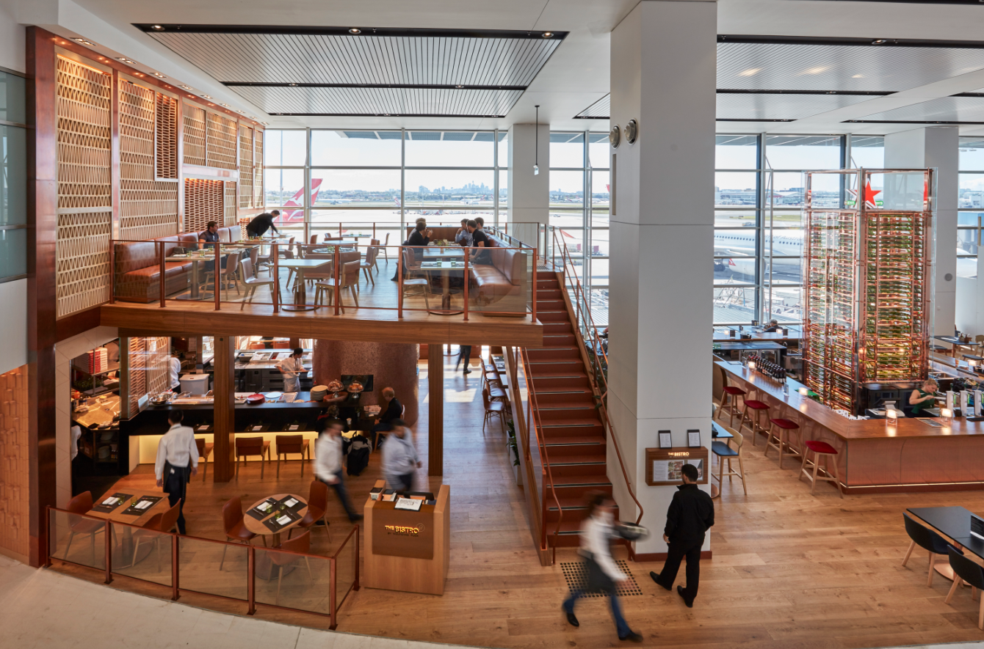
Chefs have become jet-setting stars in their own right – but you don’t need to look too hard for a close encounter at Sydney Airport.

Here’s our round-up of the best bites at Sydney Airport showcasing some of the hottest chefs around.

The Bistro by Wolfgang Puck

If you want a taste of star power, a visit here will put you in good company. Internationally acclaimed chef-to-the-stars Wolfgang Puck first burst onto the food scene with his flagship restaurant Spago in the 1980s. Over the decades, the Michelin-starred chef has honed his gourmet credentials, including catering the Oscars for the past 21 years.

Puck has now opened his first Australian venture in the T1 International terminal’s City View precinct, focusing on casual fare using the best possible ingredients.

Spanning two levels, the restaurant looks fantastic with views of the city skyline, but the food is the leading act. Slip into pre-flight mode with melt-in-your-mouth steak frites with asparagus, gourmet pizzas or the Australian Wagyu burger. If it’s breakfast time, try the cinnamon-spiced buttermilk pancakes with salted maple butter. Heavenly.

Benny Burger

When it comes to celestial stars of the culinary kind, Shannon Bennett shines a super-bright light. Acclaimed not only here but internationally, this famous foodie’s imaginative, creative and never-compromised approach to dining has influenced a generation of chefs.

So, while you may not have had time to pop down to Melbourne lately and enjoy his multi-award-winning Vue de Monde restaurant, you can savour his delicious fare in the form of the perfect burger at his first-ever Benny Burger (affectionately named after his father).

Bennett delivers a feel-good factor with every bite and the signature burger The Chang, a combination of Blackmore Wagyu beef, a free-range fried egg and pickled beetroot, is not to be missed.

Kitchen by Mike

Sydney’s own star chef, the much-loved Mike McEnearney, will bring his celebrated eatery Kitchen by Mike exclusively to Sydney Airport T1 International terminal in January.

Reminiscent of its hugely popular former site in industrial Rosebery, Kitchen by Mike will serve up his classic wood-fired chicken with young carrots and aioli, and pork belly with Granny Smith apple chutney, cucumber mirin and ginger salad.

Did we mention it will only be available at Sydney Airport?
Sydney Airport has just launched the ultimate gift for you and your jet-setting family and friends – the official Sydney Airport gift card. Just in time for Christmas, treat a traveller to a gift card so they can try these celebrity-led eateries. Head to www.sydneyairport.com.au

