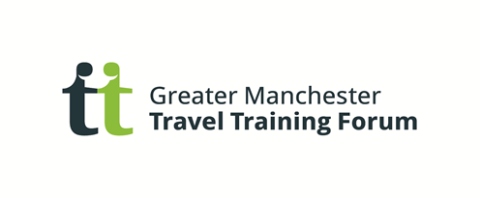

Travel Training In Stockport.

Travel Training by Pure Innovations is all about moving young people from provided transport and teaching them to travel on their own. Travel training has been shown to give people greater control in their lives, empowering them to make decisions and enabling them to take advantage of opportunities in their communities and to help achieve an independent and integrated adulthood.

Pure Innovations’ travel training team provide packages of support to young people in three areas of Greater Manchester in Partnership with Stockport, Bolton and Bury Local Authorities.

We believe the best way for young people to learn to become an independent traveller, is to make the training experience as real and as practical as is possible.

Therefore a Pure travel training program is:-

A One to one individually tailored programme to help a young person develop independent travel skills and problem solving skills. Every young person will be taught entirely to their own ability with an individual training plan.

- A dedicated trainer works 1:1 with a young person at the time they travel to and from school/college.
- The program is taken entirely at the young person’s pace
- It focuses on what the young person finds difficult i.e road safety; problem solving; stranger awareness.
- Parents/carers consent is sought continually as the program progresses.
- Training takes place in 4 stages in a gradual move to independence.

In addition to a full travel training program we also offer parents packs as a vehicle for parents or other appropriate adults to deliver travel training to their young person with support from us. We also deliver sessions within a classroom setting with groups of young people in order to develop an awareness of the issues to consider when traveling independently, such as preparing for a journey and stranger awareness. These sessions can be invaluable as a precursor to a full travel training program; or to enhance safer travel skills in wider life.
Young people have benefitted across the three schemes from group work, parent packs and learning travel routes to employment, work experience, groups/clubs and social routes; all enabling a young person to reach their full potential with individualised support to live active and integrated lives.

Successes thus far: (as at May 2104)
Since June 2010 110 young people have become independent travellers.

For more information on Travel Training in your area or to make a referral to the program, please contact your local Travel Training Co-ordinator:-

Lynn Bradley- 07712390652

Lynn.bradley@pureinnovations.co.uk

Here are links to videos of young people we have travel trained:

http://www.pureinnovations.co.uk/stories/chelseas-story/
http://www.pureinnovations.co.uk/stories/emilys-story-travel-training-bury/
http://www.pureinnovations.co.uk/stories/sebastians-story/
http://www.pureinnovations.co.uk/stories/josh-story/
http://www.pureinnovations.co.uk/taste-of-travel-training/
http://www.pureinnovations.co.uk/fun-day-travel-training-in-bolton/
http://www.pureinnovations.co.uk/travel-training-celebration-2013/

You can keep up to date with the latest information on travel training, watch videos on travel training in action and read case studies of some of our young people by checking out our website:
http://www.pureinnovations.co.uk/what-we-offer/independence/travel-training/
twitter https://twitter.com/PureTransitions, or You Tube feed
http://www.youtube.com/user/PureInnovations

