

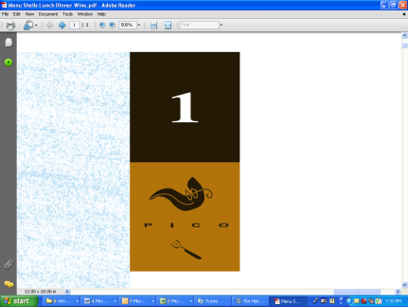

**DINNER**

**6:00pm to 10:00pm**

**AVAILABLE EVERY NIGHT**

**APPETIZERS**

**ROASTED BEETS**

**Horseradish Cream, Green Apple, Candied Walnuts**

**PAN SEARED CALAMARI**

**Cherry Tomato, Garlic, Basil, Lemon, Arugula**

**TUNA TARTARE**

**Ponzu, Sesame Oil, Avocado, Nori Crisp**

**GRILLED OCTOPUS**

**Hummus, Cucumber, Pickled Vegetables**

**MAIN COURSES**

**GRILLED MEDITERRANEAN BRANZINO**

**Green Pea Pesto, Crushed Potatoes, Romesco**

**N.Z.LAMB RACK**

**Artichoke Barigoule, Baby Turnip, Salsify, Lamb Jus (+$6)**

**TAGLIATELLE**

**Summer Black Truffle, Spring Onion, Oyster Mushrooms**

**MARYS FARM ORGANIC CHICKEN**

**Little Gem Lettuce, Marble Potatoes, Lemon-Herb Butter**

**DESSERTS**

**WARM CHOCOLATE MOLTEN CAKE**

**Pistachio Streusel, Vanilla Ice Cream**

**PANNA COTTA**

**Yuzu, Tangerine, Coconut Sorbet, Pineapple**

**CARAMELIZED APPLE TART**

**Cranberry Gelée, Goat Cheese, Crème Fraiche Ice Cream**

$49