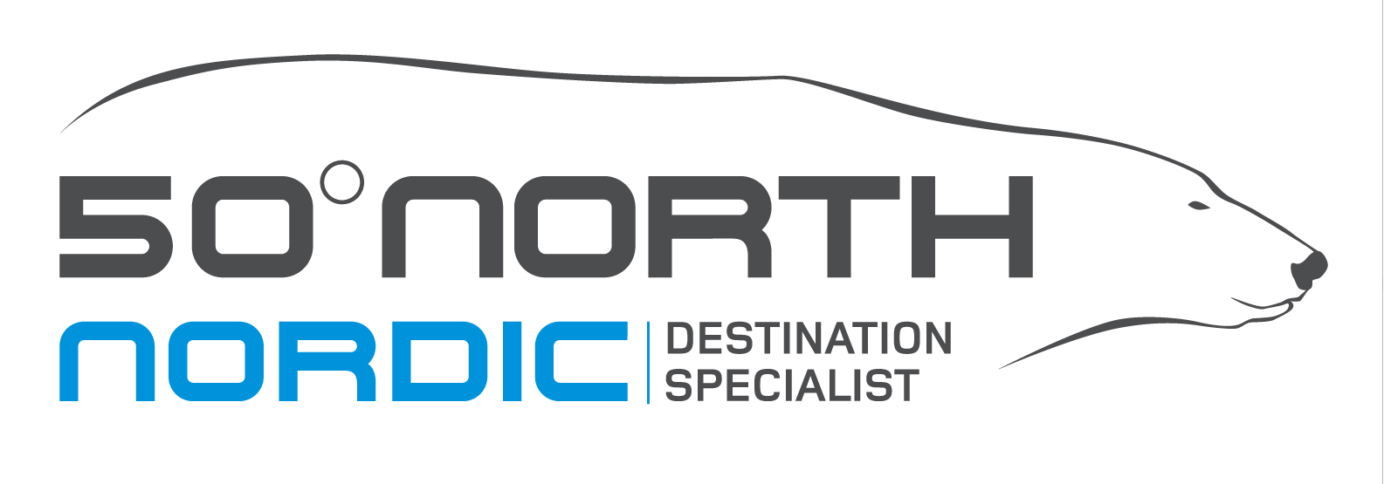 | Image banks to access

We have a small collection of 50 Degrees North images (mostly of our hotels and small group tours). For professional images, we would recommend accessing the image banks of our partners, the tourist boards of our region. These can be accessed with a password and are easy to use. Most of the time, the password is provided immediately. If you are looking for something more specific, please don’t hesitate to ask.

Norway:

Fjord Norway

https://imageshop.no/en/fjordnorge/All#/w=203&s=&info=2&sortby=CREATED_DATE

Visit Norway

https://imageshop.no/en/reiseliv/All#/w=285&s=&preview=1&info=2&sortby=CREATED_DATE

Northern Norway (Northern Lights)

http://foto.nordnorge.com/no

There is an image bank for each region of Norway so please ask if you would like access to any others and cannot find them.

All the Nordic capital cities have an image bank each as well (Helsinki, Oslo, Stockholm and Copenhagen).

Sweden:

http://imagebank.sweden.se/

http://mediabank.visitstockholm.com/

Denmark:

http://visitdenmark.digizuite.dk/

Finland:

http://imagebank.visitfinland.com/login/RegisterMek.aspx?l=EN

Faroe Islands:

https://vfi.photoshelter.com/gallery-collection/VFI-Foreign-press-TO-s/C00005DxkKzVnGuA

Greenland:

https://visitgreenland.photoshelter.com/index

Estonia:

http://photos.visitestonia.com/eng/

Iceland:

These are quite limited so ask if you need anything specific. Iceland is the one country in our collection that doesn’t provide a good free image bank.

http://www.iceland.is/press-media/photos

###

About 50 Degrees North:
50 Degrees North Pty Ltd is a wholesale travel operator specialising on the area north of the 50th parallel north. The company is fully licensed, with offices in Norway, Australia and Canada.

For further media contact:
Jayde Kincaid – 1300 422821 / jk@fiftydegreesnorth.com

