1st Annual Car Show **SUNDAY: August 13, 2017 11 AM – 3 PM**

**PARX CASINO – Bensalem, PA 19020 Enter from Driveway via Richleu Rd.**

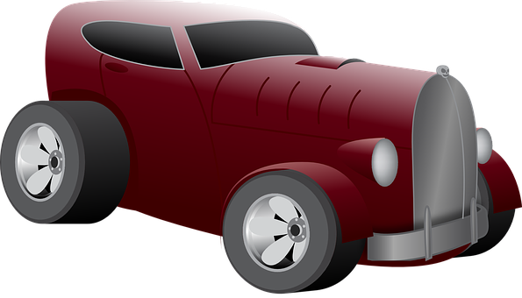



**$20 Pre-Entry Fee / Registration 9 AM Til 11 AM**

**All Makes, Models & Motorcycles Are Welcome**



**DASH PLAQUES FOR FIRST 100 CARS**

**TROPHIES DONATED BY PARX CASINO**

**DJ, MUSIC**

**FOOD VENDORS**

**50/50**

**PARTS VENDORS & CRAFT TABLES $25**

=====================================================================================Pre-Registration $20.00 (Must be postmarked by August 5, 2017). Registration Day of Show $25.00 Dash Plaques to the first 100 Pre-Registered Vehicles

REGISTRATION FORM (PLEASE COMPLETE)

Name: _______________________________________ Club Affiliation: _____________________________________

Address: __________________________________ City: _____________________________ State: _____ Zip: ________

Email: ____________________________________ Phone: ________________________

Car Make: ___________________ Model: _______________ Year: _____ Body Style: ___________ Color: ___________

I understand Bucks County Tour of Honor & Parx Casino is not responsible for loss or injury to me or my property anytime during this show. I expressly release the promoters from any liability for such loss or injury. I also agree to provide and pay my own insurance. Alcohol is strictly forbidden on the grounds during the show. By Signature below, I agree to these terms.

**Signature: ______________________________________________ Date: __________________**

**Make checks payable to: Bucks County Tour of Honor**

**Please mail checks to: Jerry Fretz, 945 Henning Road, Perkiomenville, PA 18074**

**For more show information contact:**

**Jerry (215) 208-4278** **Barry (215) 669-1812**

Visit our Website at:

[www.buckscountytourof](http://www.buckscountytourof) honor.org